# Problem 3. Portal

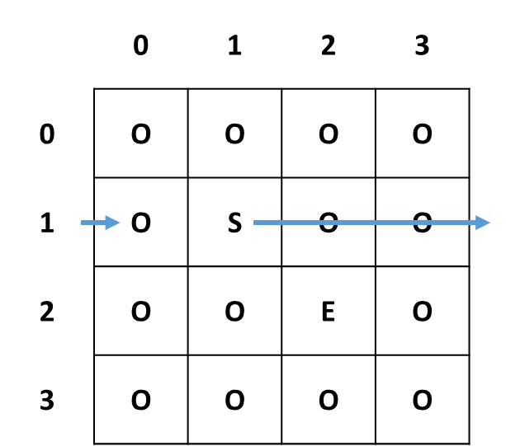You are on the path to copyright a new technology that makes teleportation possible. As you are not sure if it is dangerous, the tests are conducted in a closed environment using robots. The room in which the tests are made is a **two-dimensional jagged array**.

The robot **always starts at the room start** (S) and his mission is to **escape** the room. He can travel in every one of the four directions by receiving input from the scientists. However, the robot **can teleport through the walls** so when he reaches the end of the room **he reappears from the opposite side**. For example, if a robot starts at [1, 1] in the shown matrix and he receives input "RRR", he will end up at [1, 0] as shown on the first picture.

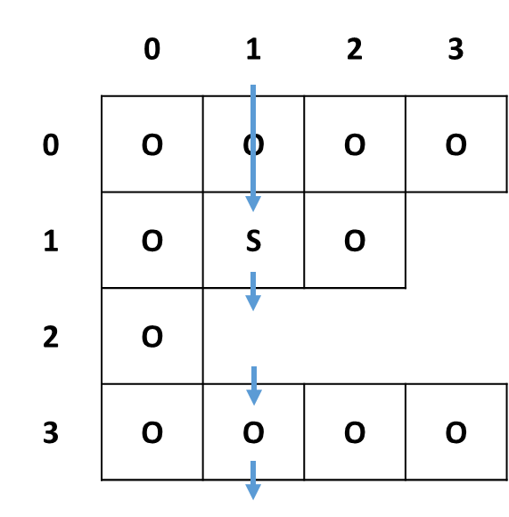If the room is not square and there is an empty space on the robot's path, he will simply teleport to the next existing cell in his direction. For example, if a robot starts at [1, 1] and he receives input "DDD", he will end up at [1, 1] as shown on the second picture.

Тhe room will have a **start** and **at least one exit**; all **other** cells are marked as empty:

* **Start (S)** – the cell from which the robot starts
* **Exit (E)** – the cell at which the robot exits the matrix
* **Empty cell** (O) – nothing (O is a character, not a number)

If a robot reaches the exit, print "Experiment successful. {turn count} jumps required."

If the robot can't find the exit print " Robot stuck at {row} {column}. Experiment failed."

## Input / Constrains

* On the **first line** of input you will get **N,** the **size of the matrix.** N will be in the range [0…100]
* On the next N lines, you will receive **the actual matrix**
* On the last line you receive a **string containing the directions the robot will be travelling**

## Output

* If therobot **can't reach the exit** print **"Robot stuck at R C. Experiment failed."** Where R is the row and C is the column that the robot died
* If the robot **reaches an exit** print **"Experiment successful. T turns required."** Where T is the number of turns that took the robot to reach the exit

## Examples

|  |  |
| --- | --- |
| **Input** | **Output** |
| 3  OOO  OSO  OOE  DR | Experiment successful. 2 turns required. |
| **Input** | **Output** |
| 5  OOOOS  OOOO  OO  OOOOO  OOOOE  DLUU | Robot stuck at 0 3. Experiment failed. |